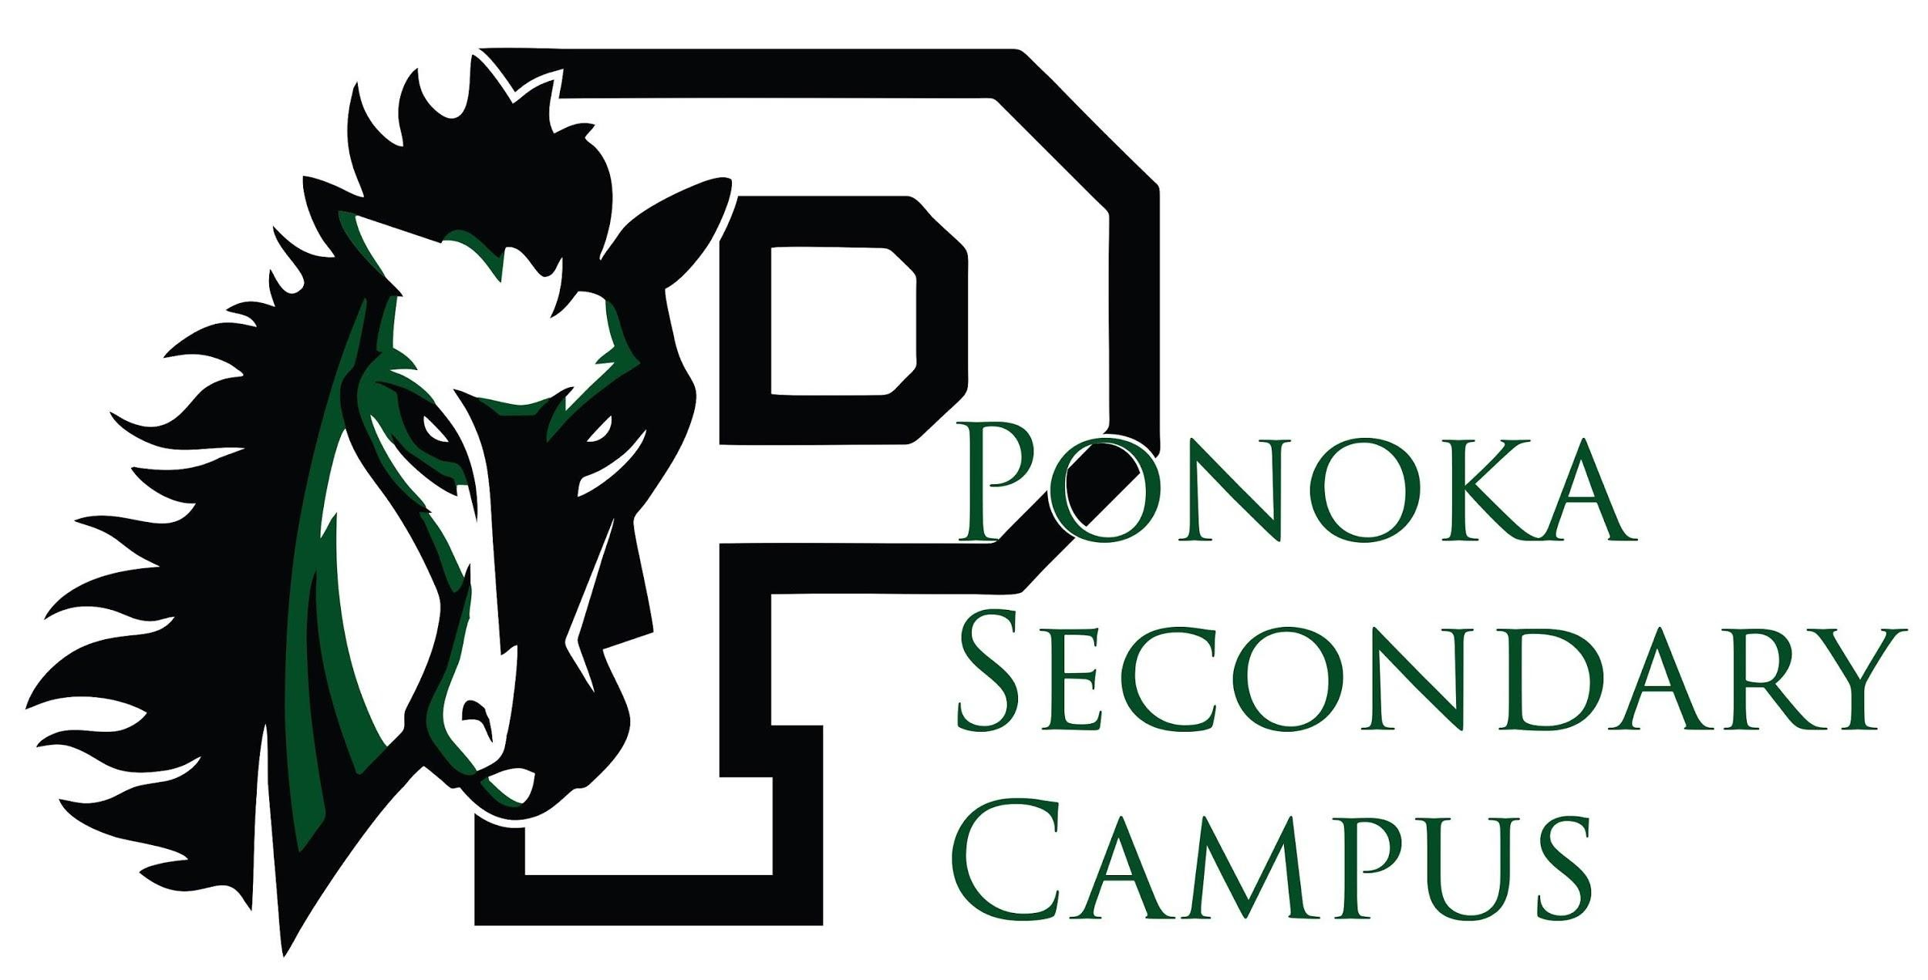
School Supply List
2022 - 2023

Classroom Supplies:

- 1 30cm Ruler
- 1 Glue stick (Junior High Only)
- 2 Binders – 2 Inch; zipped binders preferred
- Dividers
- Highlighters (at least 2 colors)
- Loose-leaf Paper ~ 500 sheets (or coil notebook for each subject)
- Pencil Crayons or Markers (Junior High Only)
- Pencils – approx. 10 HB
- Pens – 5 Blue or Black
- Scientific Calculator ** you do not need to invest in a graphing calculator until Grade 10
- Scissors (Junior High Only)
- Sharpie - Black Fine Point
- Hair Elastics (If needed for: Foods, Construction, PE…etc)

Physical Education

- Students are REQUIRED to change for Physical Ed
- Deodorant (no spray)
- T-shirt
- Shorts or sweatpants
- Gym shoes (non-marking soles)
** Broncs Gym Strip with Shorts and T-Shirt is available for purchase ($35)

Locks for Lockers
Students must use locks which are provided by the school.
If locks are lost, students will be charged a $10 replacement fee

