September 2, 2022 - Principal’s Message, Mr. Cody Baird
Welcome to our regular Principal’s Message that will be sent throughout the school year!
The staff at PSC are excited and eager to start the 2022/2023 school year, and we wanted some information to get to everyone early as we plan for our students.
First Day(s) of school in September 2022-2023
Our office is open and available from 8:00 am - 4:00 pm. If you have any questions or need support with registration, please come visit us or give us a call.
Tuesday, September 6, 2022 - 1st day of school for grade 7’s ONLY!
We will have a staggered entry to introduce our new grade 7’s to PSC. Tuesday, September 6th we will be an orientation day for grade 7’s and our students in the Lifeskills program. They will begin the day with their TA (Teacher Advisor) who will give them a tour, introduce them to the school procedures and answer all questions students have. This TA will run all morning to give students time to settle in. Then in the afternoon students will run through a condensed school day ending normally at 3:25pm.
Wednesday, September 7, 2022 - School Begins for Everyone
On Wednesday, September 7th - Grades 8-12 will begin school and our grade 7’s will continue. All students will begin their day with their Teacher Advisor and confirm their schedules, receive lockers and go through procedures. Starting at 10:00am students will start a condensed school day ending normally at 3:25pm.
Thursday, September 8, 2022 - Regular School day for everyone at PSC.
Students will still meet with their TA teachers today during their Flex / LSA block to ensure that students are settling into the school.
Friday, September 9, 2022 - Regular School day for everyone at PSC.
Demographic Update: You will receive an email from Wolf Creek Public Schools outlining and linking the process so parents/guardians can complete their children's demographic update form which acts as their registration form. Please ensure these are complete. Without these forms completed there are some limitations to what services your child will have access to. The email outlines:
Every family (new and returning) will receive an email, in regards to a Demographic Update form for each of their PreK-12 students attending a Wolf Creek school in the 2022-2023 school year. We require parents follow the instructions on the email and submit the information ASAP. Once this online process is completed, the information is then updated into your child's profile within PowerSchool. It is important that schools have correct and current phone numbers, addresses, contact information, medical information, permissions, etc for all students. It is also important to note that failure to complete this update could impact your child's participation in physical activities as well as access to digital tools and services.
We are making some significant changes to our Parent/Guardian and Emergency Contacts in PowerSchool, so for this year only, you will be required to re-enter this information from scratch (no pre-populated information). Please read the requirements for these sections carefully when completing the forms.
You will receive an email to the email address attached to your Parent Portal account. If you don’t have a Parent Portal account, please contact your child's school office.
Follow the directions in the email to complete a 2022-2023 Demographic Update form for each PreK-12 student you have in a Wolf Creek school. If you did not receive an email asking you to update your child's student profile, please check your spam/junk folder.
Using a phone or tablet to complete these forms may cause issues for some users. We recommend using a desktop, laptop or Chromebook.
If you are having issues submitting the form, accessing your Parent Portal account or require access to a device to complete this form, please contact your child’s school office.
Online Student Demographic Update forms are due Sept 15, 2022.
SPORTS ARE STARTING UP!
Football: Sr. Broncs Football is running, PSC students grades 10-12 are welcome to join practice 4:00-6:00pm. Bring a water bottle and we will see you on the field!
Volleyball: All girls from grades 9 -12 that are interested in playing for the JV or Sr. Broncs volleyball teams have tryouts on September 8 and September 9, 2022 from 3:40pm - 5.00pm. Please ensure you bring proper athletic attire and a water bottle. Any questions please chat with Mrs. Amdam, Mr. McLeod or Mr. Labrie.
Jr. High Girls Volleyball: Tryouts will be the following week of September 12th-16th. Specific dates and times T.B.A.
Boys Volleyball: Interest is back up and running and we will be looking at having not only 1 but 2 boys volleyball teams this year.
We will have a noon hour informational meeting on Thursday, September 8th for all interested Grade 9-11 boys - in Mr. McLeod's room.
There will also be a noon hour informational meeting on Friday, September 9th for all interested Grade 7-8 boys - in Mr. McLeod's room.
Stay tuned for tryout dates and times
Cross Country: This will start Thursday, September 9th for all students in grades 7-12. Practices will run Monday’s, Tuesday’s and Thursday’s after school. If you are interested please meet in the GP room (cafeteria area) at 3:45pm on Thursday the 9th.
School Supplies: The school supply list can also be found on the homepage of our website:
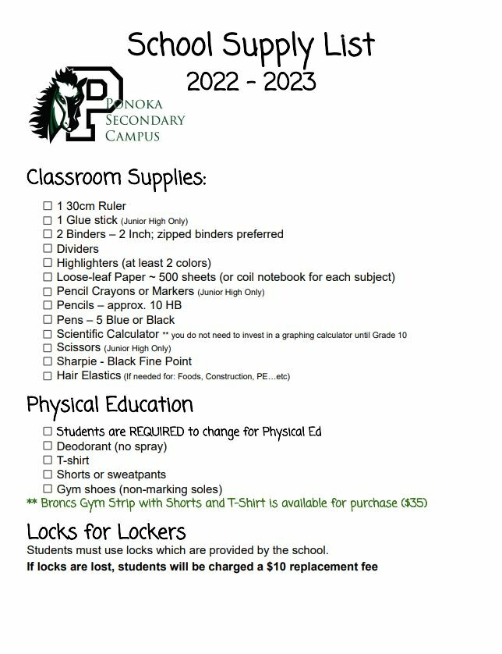
Meet the Teacher Evening
I would like to invite parents and guardians along with their children to our “Meet The Teacher Evening” Thursday, September 15, 2022 from 4:00pm-7:30pm at the school. This is a drop in event, no appointment necessary, come if you can.
School Photos: School photos are Friday, September 23, 2022.
Jr. High LSA: Our Junior High students have 30 minutes a block called LSA (Life, Skills and Attitudes). This time is to enrich our students with skills they will need to be successful in their academic futures. These sessions are provided by teachers and students who will rotate through different sections that include lessons such as: money management, measuring skills, presentation skills, global and current events, character education and hygiene / wellness. These sessions will run for 30 minutes Monday - Thursday (TA will meet on Fridays at this time).
Jr. High Flexible Groupings: Our Jr. High teachers have been working hard developing strong pre-assessments to determine where our students are needing support with the outcomes they will be working through for a unit. Once students have settled in, our grade 7-9 teachers will deliver their pre-assessments, and will create class lists based on student needs. These lists will be specific depending on each student's needs, on the current outcomes in each core course. When students get to their next unit outcomes they will again be pre-assessed and the groupings will change again depending on the support or enrichment different students need.
High School Flex: We will start our high school Flex supports September 12, 2022. This is a 35 minute block offered every Monday - Thursday where students can access their teachers for extra support. Please encourage your children to attend Flex if they need any type of support as this is the perfect opportunity for all students to seek individualized support, and is our largest intervention in High School.
Youth Center and Mentorship Programs: The Ponoka Youth Center is running “Raise the Grade” again this year! This is a FREE tutoring service for ALL PSC students at the Youth Center Tuesday’s, Wednesday’s and Thursday’s from 2:00-5:30pm.
Jr. High Montreal / Quebec City / Ottawa Trip: For any students interested in our Jr. High trip there will be a parent information / recruitment meeting September 16, 2022 at 7:00pm in the school.
Cafeteria: Our cafeteria will not be open during the first week of school. We should have all of our food orders in and be running for the second week of school starting September 13, 2022.
Cody
“Work hard, be kind and amazing things will happen.”
Conan O’Brien

